Heat Pipes – Theory and Design

# 1.0 Overview

Overall Thermal Resistance of a Heat Pipe (should be low):

$$R=\frac{T_{hot}-T_{cold}}{\dot{Q}}$$

Operating limits for a wicked heat pipe (limits may be considered in isolation):

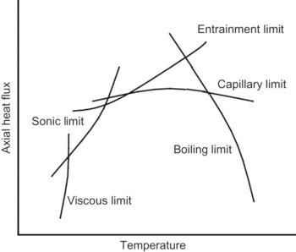

* To operate,
 $$ΔP_{c, max}≥ΔP_{l}+ΔP_{v}+ΔP_{g}$$

 + Where $ΔP_{c, max}$ is **the maximum capillary pumping pressure**
  + $ΔP_{l}$ is the pressure drop required to return liquid from the condenser to evaporator
  + $ΔP_{v}$ is the pressure drop required to cause vapor to flow from evaporator to condenser
  + $ΔP_{g}$ is the pressure due to the **gravitational head** (inclination dependent)

The maximum allowable heat flux for which the equation above remains true is the **capillary limit**.

# 2.0 Theory

**Gravitational Head Pressure Difference:**

$$ΔP_{g}=p_{l} g l\sin{ϕ}$$

* $p_{l}$– liquid density
* $g$– gravitational acceleration
* $l$– length of the heat pipe
* $ϕ$– angle b/w pipe and horizontal, evaporator above condenser is positive

**Surface Tension:**

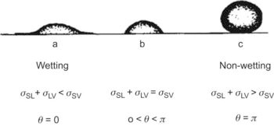

* $σ_{sl}$– surface energy per unit area between solid and liquid
* $σ_{lv}$– surface energy per unit area between liquid and vapor
* $σ_{sv}$– surface energy per unit area between solid and vapor
* $θ$– contact angle

**In heat pipes, wetting liquids are always used, as the give rise to capillary action!**

**If contact angle is negative, liquid resists capillary action!**

**Capillarity (capillary action):**

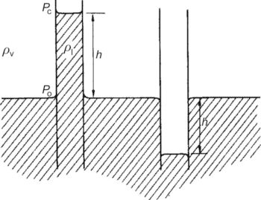

Capillary action (for a circular tube of radius r):

$$\left(ρ_{l}-ρ_{v}\right)gh=\frac{2σ_{1}}{r}\cos\left(θ\right)≅ρ_{1}gh$$

* $ρ_{l}-$ liquid density
* $ρ_{v}$– vapor density
* $θ$– contact angle

Capillary force:

$$σ_{1}\cos\left(θ\right)≅\frac{ρ_{1}ghr}{2}$$

Capillary Pressure…

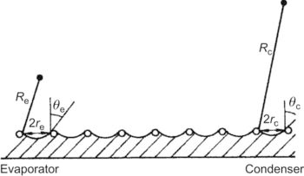

$$ΔP=\frac{2σ_{1}}{R}$$

Capillary Pressure At Evaporator:

$$ΔP_{e}^{'}=2σ_{1}\frac{\cos{θ_{e}}}{r_{e}}$$

* $r$– the effective radius of the wick pores
* $θ$– contact angle

Capillary Pressure At Condenser:

$$ΔP_{c}^{'}=2σ_{1}\frac{{\cos{θ}}_{c}}{r_{c}}$$

**Flow Regimes -** For fully developed flows:

Reynolds number:  
laminar/turbulent transition in heat pipe: 2100 … <2100 is laminar, >2100 is turbulent

$${R_{e}}_{d}=\frac{ρvd_{e}}{μ}$$

* $R_{e_{d}}$– Reynolds number
* $ρ$– fluid density
* $v$– velocity
* $d_{e}$– hydraulic diameter (representative dimension) = $4 x\frac{cross-sectional area}{wetted perimeter}$
* $μ$– dynamic viscosity

Velocity:

*For detailed velocity/pressure gradient relationships see Chapter 2 Section 2.3.3.2*

*See 2.3.3.3 For Turbulent Flow Equations*

**Liquid Phase Pressure Difference (Flow in Wicks):**

Mass flow varies in the evaporator and condenser regions, so an effective length is necessary.

$$l_{eff}=l_{a}+\frac{l_{c}+l_{e}}{2}$$

* $l_{eff}$ = total effective length for fluid flow
* $l_{a}$ = adiabatic section length
* $l_{c}$ = length of the condenser section
* $l_{e}$ = length of the evaporator section

For homogeneous wicks:

$$A_{f}=Aϵ=π\left(r_{w}^{2}-r_{v}^{2}\right)ϵ$$

* $A_{f}$– Flow cross-sectional area
* $ϵ$– The fractional void of the wick
* $r_{w}$– The outer radius of the wick
* $r_{v}$– The inner radius of the wick
$$ΔP_{l}=\frac{b{ μ}_{l }\dot{Q} l_{eff}}{π \left(r_{w}^{2}-r_{v}^{2}\right) ϵ r_{c}^{2} ρ_{l} L}$$

* $b$– dimensionless constant to account for tortuosity (10 < b < 20), b = 8 for round tubes.
* $\dot{Q}$– heat input = $\dot{m}L$
* L – Latent hear of vaporization

**OR**

**Darcy’s Law:**

$$ΔP_{l}=\frac{μ_{l}l_{eff}\dot{m}}{ρ_{l}KA}$$

* $K$– wick permeability

*See section 2.3.4.3 for Non-Homogeneous Wicks*

**Vapor Phase Pressure Difference:**

Radial Reynolds Number (positive in evaporator section, negative in condenser section):

$$R_{e_{r}}=\frac{ρ_{v}v_{r}r_{V}}{μ_{v}}$$

* $v_{r}-$ radial velocity component

Total vapor pressure drop in the evaporator region (laminar flow assumption):

$$ΔP_{ve}=ΔP_{v}^{'}+ΔP_{v}^{''}=ρv^{2}+\frac{8μ\dot{m}}{ρπr_{v}^{4}}\frac{l_{e}}{2}$$

Total vapor pressure drop in the condenser region (laminar)

$$ΔP_{vc}=-ρ_{v}^{2}$$

Total vapor pressure drop in the adiabatic region (laminar):

$$ΔP_{va}=\frac{8μ\dot{m}}{ρπr_{v}^{4}}l_{a} r_{e}<2100$$

Therefore, total vapor pressure drop with **NO pressure recovery:**

$$ΔP_{v}=ΔP_{ve}+ΔP_{vc}+ ΔP_{va}=ρv^{2}+ \frac{8μ_{v}\dot{m}}{ρπr_{v}^{4}}\left[\frac{l_{e}+l_{c}}{2}+l_{a}\right]$$

And, total vapor pressure drop with **FULL pressure recovery:**

$$ΔP_{v}=ΔP_{ve}+ΔP_{vc}+ ΔP_{va}=\frac{8μ_{v}\dot{m}}{ρπr_{v}^{4}}\left[\frac{l_{e}+l_{c}}{2}+l_{a}\right]$$

**Entrainment:**

Weber number (We) is the ratio of inertial vapor forces to liquid surface tension forces. It gives an idea of how likely entrainment will be:

$$We=\frac{ρ_{v}v^{2}z}{2πσ_{1}}$$

* $z$– a dimension characterizing the vapor-liquid surface. (related to wick spacing in a heat pipe)

Entrainment may occur when We is of the order 1. Therefore, the limiting vapor velocity $v_{c}$ is

$$v_{c}=\sqrt{\frac{2πσ_{1}}{σ_{v}z}}$$